***S:\Admin & Finance\Grants Admin\FY 2019 Grants\FY19 Grants\Career Pathways 10/24/2018***

**Model Online Application for FY 2019 Early Childhood Education Career Pathways Grant (Fund Code 325)**

**General Text Changes to FY 2019 EPS Online Application:**

* All headings should be changed to "**FY 2019 Early Childhood Education Career Pathways Grant "**
* Change all references of"**FY 2018**" to **"FY 2019" in the body of the paragraphs.**

Change text to "FY 2019 Early Childhood Education Career Pathways Grant (Fund Code 325)"

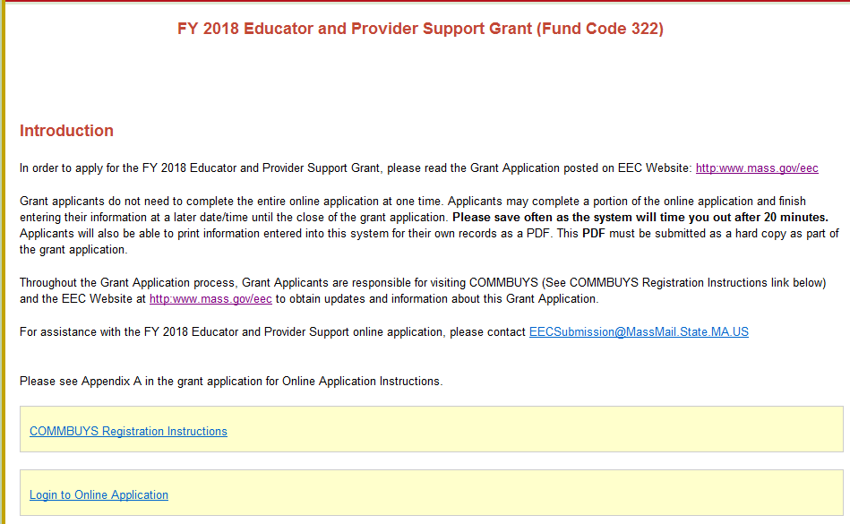

Change text to "FY 2019 Early Childhood Education Career Pathways Grant

Change text to Appendix C

Text should read as follows:

FY2019 Early Childhood Education Career Pathways Grant (Fund Code 325)

Introduction

In order to apply for the FY 2019 Early Childhood Education Career Pathways Grant, please read the Grant Application posted on **COMMBUYS** at www.commbuys.com.

Grant Applicants do not need to complete the entire Online Application at one time. Applicants may complete a portion of the Online Application and finish entering their information at a later date/time until the close of the Grant Application. Applicants will also be able to print information entered into this system for their own records as a PDF. This **PDF** must be submitted as a hard copy as part of the Grant Application.

**Please save often as the system will time you out after 30 minutes.**

Throughout the Grant Application process, Grant Applicants are responsible for visiting **COMMBUYS** (See COMMBUYS Registration Instructions link below)and the EEC Website at<https://www.mass.gov/orgs/department-of-early-education-and-care> to obtain updates and information about this Grant Application.

For assistance with the FY 2019 Early Childhood Education Career Pathways Grant Online Application, please contact EECSubmission@massmail.gov.

Please see **Appendix C** in the Grant Application for the Online Application Instructions.

COMMBUYS Registration Instructions – link Delete link

Login to Online Application- link

# Registration: Username & Password:

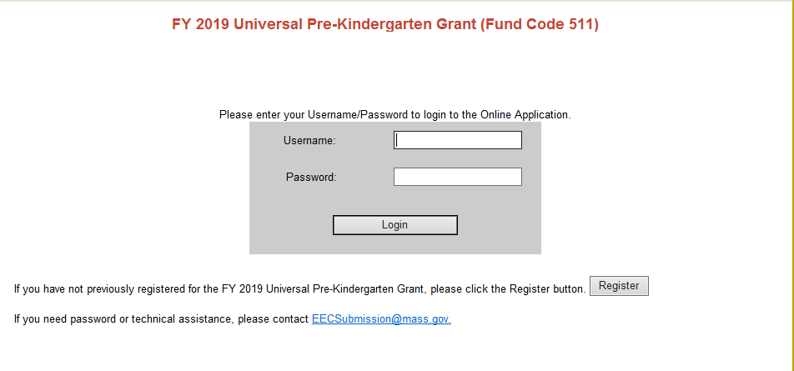

Change text to "FY 2019 Early Childhood Education Career Pathways Grant (Fund Code 325)"

Change text to “FY 2019 Early Childhood Education Career Pathways Grant”

This is a new grant application and therefore none of the applicants would have registered for this grant in the past.

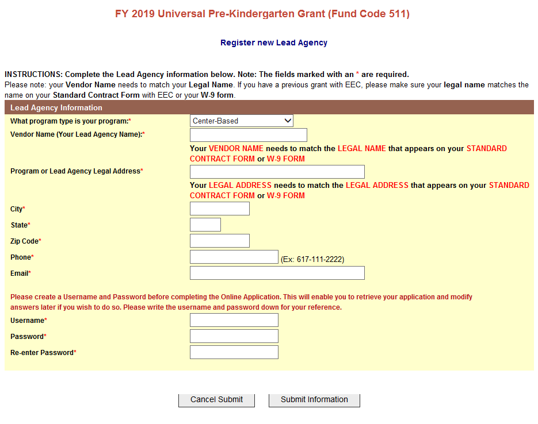

Change text to FY 2019 Early Childhood Education Career Pathways Grant (Fund Code 325)

* **HOME PAGE -**

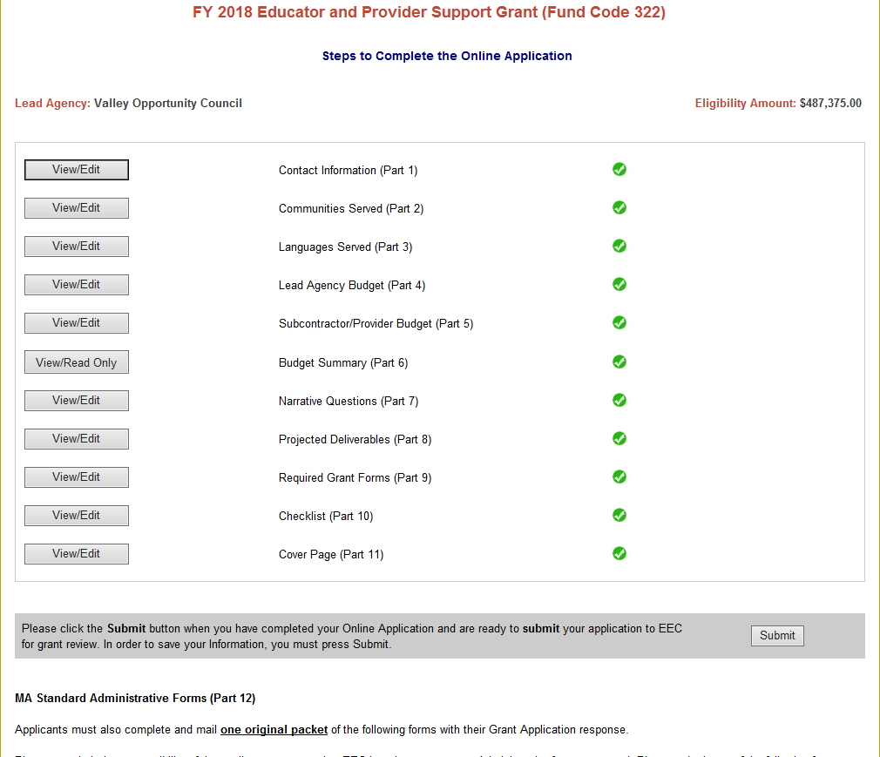

**Maximum Eligibility Amount up to** *$296,904* (per grantee, this amount has changed since the 9.24.18 online requirements document.)

**Total Budget Requested:** ______ (Note to IT: *This will be whatever they put into the lead agency budget.)*

Eligible grantees will be Massachusetts’ Community Colleges only. We do not know which colleges will apply.

**Disable/close/block** the **Subcontractor /Provider Budget (Part 5)**, **Narrative Questions (Part 7), and Projected Deliverables** **(Part 8)** buttons as grantees will not be able to enter information in these sections.

The 9.24.18 version of the Online Application requirements included Narrative Questions (Part 7); at this time (11.5.18) the Narrative Questions should be closed. Applicants will be required to upload their narrative response as a required form.

* **Part 1 - CONTACT INFORMATION:**

No changes.

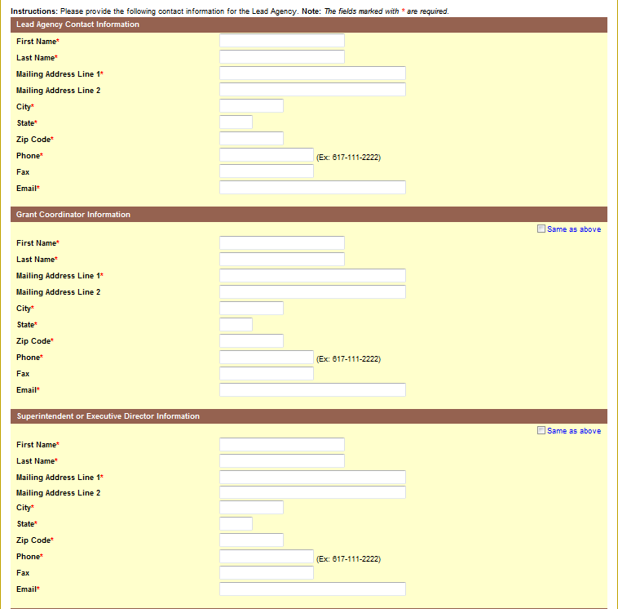

**Part 2 - COMMUNITIES SERVED:** Grantees will only be using communities served data for informational purposes- not eligibility amounts.

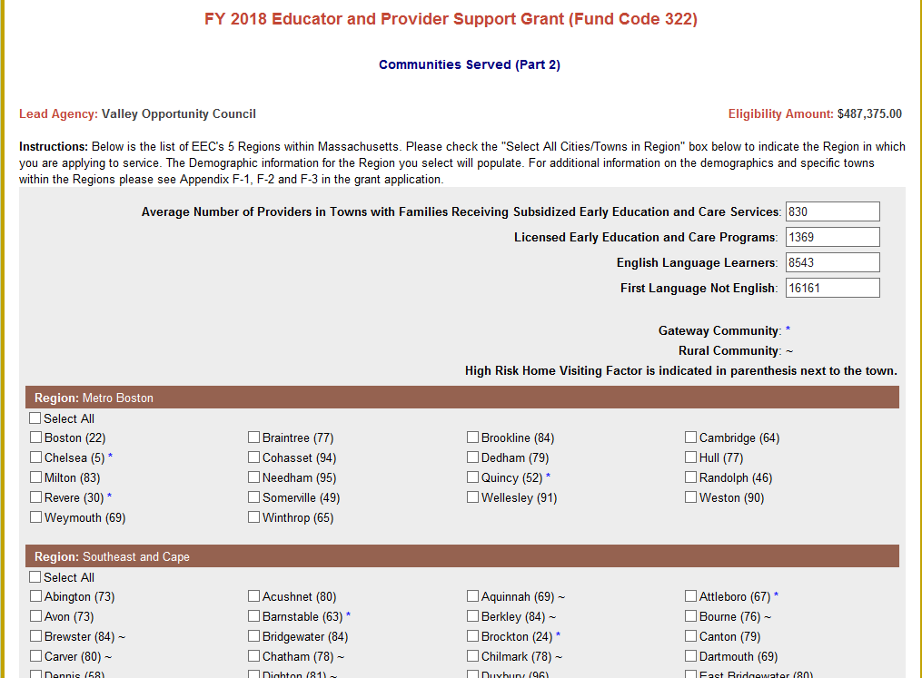

Change instructions to read: Please select the cities/towns below in your community college’s catchment area. The demographic information will automatically populate for the cities and towns chosen. This information is provided as a resource to applicants. For additional information on the demographics for specific cities and towns within the Commonwealth please see Appendices I and J in the grant application.

Display: Data Points for 322 : **list data points in this order**

1. Avg. Number of Providers in Towns with Families Receiving Subsidized Early Education and Care Services
2. Licensed Early Education and Care Programs
3. English Language Learners
4. First Language not English

6. Gateway Community: *

7. Rural Community: ~

8. High Risk Home Visiting Factor is indicated in parenthesis next to the town.

Change text to FY 2019 Early Childhood Education Career Pathways Grant (Fund Code 325)

* **Part 3 - LANGUAGES SERVED:** *No changes.*

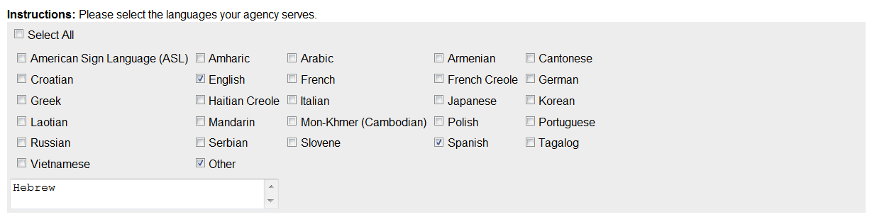

* **PART 4 - LEAD AGENCY BUDGET:**

**Instructions:** Please reference ~~the fund use section within the Grant Application and~~ **Appendix D**: FY 2019 Early Childhood Education Career Pathways Budget Guidelines for specific guidelines regarding the budget, including program and admin costs. **Note: YOU CAN ONLY ENTER WHOLE NUMBERS INTO THE BUDGET.** Funds cannot be entered into the gray boxes as these costs are considered unallowable for this grant.

Delete text

**Sample Alerts- no changes**

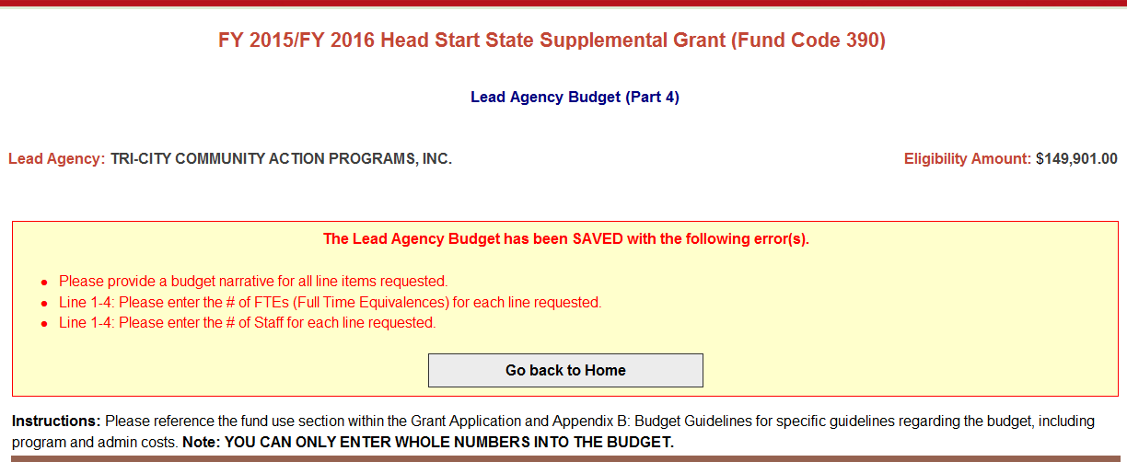



Please add the following alerts to the bottom of the Lead Agency Budget if the requirements are not satisfied:

* Fringe over 35% Alert: The 35% must be taken from the sub-totals of Administrators, Instructional/Professional and Support staff of the Lead Agency. (This alert still allows the applicant to move forward but it tells them that they must provide a breakdown of fringe).
* Line 1-4: Please enter the # of Staff for each line requested.
* Line 1-4: Please enter number of FTEs (Full Time Equivalences) for each line requested.
* Line 4: Fringe is over 35%. Please provide a breakdown in the budget narrative to account for this percentage.
* Line 5: Please provide the Rate ($) and Hr/Day/Wk/Yr/Flat for each Contractual Service requested.
* Line 10: Please provide the Indirect Cost Approval Rate.
* Please provide a budget narrative for all line items requested.
* Please provide the requested Program or Admin costs.

*Please provide a budget narrative for all line items requested.

* Please provide the requested Program or Admin costs.

**Lead Agency Budget (Part 4)**

|  |  |  |  |  |  |  |
| --- | --- | --- | --- | --- | --- | --- |
| **1. Administrators** | | | | | | |
| **Column A Column B Column C Column D Column E Column F Column G**  **Expenditure # of Staff FTE Program Admin Total Grant Budget Narrative**  **Category Costs Costs Budget** | | | | | | |
| Supervisor/Director | 0 | 0.00 |  | $0.00 | $0.00 |  |
| Project Coordinator | 0 | 0.00 | $0 | $0 | $0 |  |
| Stipend |  |  | $0 | $0 | $0 |  |
| Other | 0 | 0.00 | $0 | $0 | $0 |  |
| **Administrators**  **Sub-Total** | **0** | **0.00** | **$0** | **$0** | **$0** |  |
| **2. Instructional/Professional Staff** | | | | | | |
| **Column A Column B Column C Column D Column E Column F Column G**  **Expenditure # of Staff FTE Program Admin Total Grant Budget Narrative**  **Category Costs Costs Budget** | | | | | | |
| Advisor | 0 | 0.00 | $0 |  | $0 |  |
| Clinician |  |  |  |  |  |  |
| Coordinator | 0 | 0.00 | $0 |  | $0 |  |
| Educator/Instructor | 0 | 0.00 | $0 |  | $0 |  |
| Home Visitor |  |  |  |  |  |  |
| Specialist | 0 | 0.00 | $0 |  | $0 |  |
| Stipend |  |  | $0 | $0 | $0 |  |
| Other | 0 | 0.00 | $0 | $0 | $0 |  |
| **Instructional/ Professional Staff Sub-Total** | **0** | **0.00** | **$0** | **$0** | **$0** |  |
| **3. Support Staff** | | | | | | |

Add column titles

Column A: Expenditure Category

Column B: # of Staff

Column C: FTE

Column D: Program Costs

Column E: Admin Costs

Column F: Budget

Column G: Budget Narrative

|  |  |  |  |  |  |  |  |
| --- | --- | --- | --- | --- | --- | --- | --- |
| **Column A Column B Column C Column D Column E Column F Column G**  **Expenditure # of Staff FTE Program Admin Total Grant Budget Narrative**  **Category Costs Costs Budget** | | | | | | | |
| Aide/Paraprofessional |  |  |  |  |  | |  |
| Secretary/Bookkeeper | 0 | 0.00 |  | $0 | $0 | |  |
| Stipend |  |  | $0 | $0 | $0 | |  |
| Other | 0 | 0.00 | $0 | $0 | $0 | |  |
| **Support Staff**  **Sub-Total** | **0** | **0.00** | **$0** | **$0** | **$0** | |  |
| **4. Fringe Benefits** | | | | | | | |
| **Column A Column B Column C Column D Column E Column F Column G**  **Expenditure # of Staff FTE Program Admin Total Grant Budget Narrative**  **Category Costs Costs Budget** | | | | | | | |
| Fringe Benefits | 0 | 0.00 | $0 | $0 | $0 |  | |
| **Fringe Benefits**  **Sub-Total** | **0** | **0.00** | **$0** | **$0** | **$0** |  | |
| **5. Contractual Services** | | | | | | | |
| **Column A Column B Column C Column D Column E Column F Column G**  **Expenditure Hr/Day/Wk Program Admin Total Grant**  **Category Rate /Yr/Flat Costs Costs Budget Budget Narrative** | | | | | | | |
| Advisor | $0.00 | 0 | $0 |  | $0 |  | |
| Clinician |  |  |  |  |  |  | |
| Consultant | $0.00 | 0 | $0 |  | $0 |  | |
| Educator/Instructor | $0.00 | 0 | $0 |  | $0 |  | |
| Home Visitor |  |  |  |  |  |  | |

|  |  |  |  |  |  |  |
| --- | --- | --- | --- | --- | --- | --- |
| Specialist | $0.00 | 0 | $0 |  | $0 |  |
| Speaker | $0.00 | 0 | $0 |  | $0 |  |
| Substitute |  |  |  |  |  |  |
| Stipend |  |  | $0 | $0 | $0 |  |
| Other | $0.00 | 0 | $0 | $0 | $0 |  |
| **Contractual Services Sub-Total** |  |  | **$0** | **$0** | **$0** |  |
| **6. Supplies & Materials** | | | | | | |
| **Column A Column B Column C Column D Column E Column F Column G**  **Expenditure Program Admin Total Grant**  **Category Costs Costs Budget Budget Narrative** | | | | | | |
| Educational & Instructional Materials |  |  | $0 |  | $0 |  |
| Instructional Technology including Software |  |  | $0 | $0 | $0 |  |
| Non-Instructional  Supplies |  |  |  | $0 | $0 |  |
| Other |  |  | $0 | $0 | $0 |  |
| **Supplies & Materials**  **Sub-Total** |  |  | **$0** | **$0** | **$0** |  |
| **7. Travel** | | | | | | |
| **Column A Column B Column C Column D Column E Column F Column G**  **Expenditure Mileage Program Admin Total Grant Budget Narrative**  **Category Rate Costs Costs Budget** | | | | | | |
| Administrators (Supervisory Staff) | $0.00 |  |  | $0 | $0 |  |
| Instructional Staff | $0.00 |  | $0 |  | $0 |  |
| Other | $0.00 |  | $0 | $0 | $0 |  |

|  |  |  |  |  |  |  |  |  |
| --- | --- | --- | --- | --- | --- | --- | --- | --- |
| **Travel Sub-Total** |  |  | | **$0** | **$0** | | **$0** |  |
| 8**. Other Costs** | | | | | | | | |
| **Column A Column B Column C Column D Column E Column F Column G**  **Expenditure Program Admin Total Grant**  **Category Costs Costs Budget Budget Narrative** | | | | | | | | |
| Advertising |  |  | $0 | | $0 | | $0 |  |
| Equipment Rental |  |  |  | | $0 | | $0 |  |
| Maintenance/Repairs |  |  |  | | $0 | | $0 |  |
| Membership/ Subscriptions |  |  |  | | $0 | | $0 |  |
| Printing/Reproduction |  |  | $0 | | $0 | | $0 |  |
| Staff Training |  |  | $0 | | $0 | | $0 |  |
| Rental of Space |  |  | $0 | | $0 | | $0 |  |
| Telephone/Utilities |  |  |  | | $0 | | $0 |  |
| Direct Service  Transportation |  |  |  | |  | |  |  |
| Other |  |  | $0 | | $0 | | $0 |  |
| **Other Costs**  **Sub-Total** |  |  | **$0** | | **$0** | | **$0** |  |
| **9. Capacity Building** | | | | | | | | |
| **Column A Column B Column C Column D Column E Column F Column G**  **Expenditure Program Admin Total Grant Budget Narrative**  **Category Costs Costs Budget** | | | | | | | | |
| Professional Development Opportunities |  |  | | $0 | $0 | $0 | |  |
| Application Fees |  |  | | $0 |  | $0 | |  |

Unblock cells for Professional Development Opportunities: Program Costs and Total Grant Budget

|  |  |  |  |  |  |  |  |  |  |
| --- | --- | --- | --- | --- | --- | --- | --- | --- | --- |
| CEU Courses |  |  |  |  | | $0 | |  | |
| College Courses |  |  | $0 |  | | $0 | |  | |
| Other |  |  | $0 | $0 | | $0 | |  | |
| **Capacity Building**  **Sub-Total** |  |  | **$0** | **$0** | | **$0** | |  | |
| **10. Indirect Costs** | | | | | | | | | |
| **Column A Column B Column C Column D Column E Column F Column G**  **Expenditure Program Admin Total Grant Budget Narrative**  **Category Costs Costs Budget** | | | | | | | | | |
| Indirect Costs | **Approved Rate:** 0.0 | |  | $0 | |  | |  | |
| **Indirect Costs**  **Sub-Total** |  |  |  | **$0** | |  | |  | |
| **11. Equipment** | | | | | | | | | |
| **Column A Column B Column C Column D Column E Column F Column G**  **Expenditure Program Admin Total Grant**  **Category Costs Costs Budget Budget Narrative** | | | | | | | | | |
| Instructional  Equipment |  |  |  | |  | |  | |  |
| Non-instructional  Equipment |  |  |  | |  | |  | |  |
| Other |  |  |  | |  | |  | |  |
| **Equipment**  **Sub-Total** |  |  | **$0** | | **$0** | | **$0** | |  |
| **Lead Agency Total** |  |  | **$280,309.00** | | **$24,374.00** | | **$304,683.00** | |  |

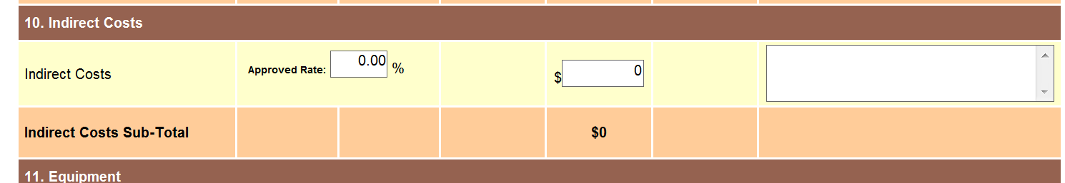

**Add text to Indirect Cost:**

* **Under no circumstances can the use of the indirect cost rate exceed the amount of funds (10% of the total grant) allocated to administrative purposes.**

12. Ancillary Services- This category needs to be blocked.

|  |  |  |  |  |  |  |
| --- | --- | --- | --- | --- | --- | --- |
| **Column A Column B Column C Column D Column E Column F Column G**  **Expenditure Program Admin Total Grant Budget Narrative**  **Category Costs Costs Budget** | | | | | | |
|  |  |  |  |  |  |  |

Change to Appendix D: FY 2019 Early Childhood Education Career Pathways Budget Guidelines

* **PART 4 - LEAD AGENCY BUDGET:** 
  + Please reference the fund use section within the Grant Application and **Appendix D: FY 2019 Early Childhood Education Career Pathways Budget Guidelines** to follow specific guidelines regarding the budget for this grant, including **program** and **admin** costs.
    - Please note: All budget lines and columns are open to enter information. However, not all budget lines and columns are allowable under this grant.
  + **Note: YOU CAN ONLY ENTER WHOLE NUMBERS INTO THE BUDGET.**
  + Error messages will appear in **RED** at the top of the Lead Agency Budget. Errors are outlines in **RED BOX(ES)** for each item that has an error. A Budget cannot be submitted with any errors.
  + Please ensure that all line items for which you claim funds have a **budget narrative** that describes how they are aligned with the purpose of the funding.
  + For all staff-related line items (#1-4), please include the **Number of Staff** and **Number of FTEs** in the corresponding columns.
    - Please note that the FTEs should not be larger than the number of staff x 1.00 FTEs.
  + For the Fringe Benefits line item (#4), please provide a narrative that includes the components of the fringe benefits, if applicable:
    - Federal Tax, State Tax, FICA, Mass Unemployment, Health Insurance, Worker's Compensation, Medicare, SUTA, Other Retirement Systems, Other.
    - If the amount is coming from another source, please provide the name of the source(s) in Budget Narrative.
  + If the 35% allocation for Fringe has been exceeded, an Alert will appear and a breakdown of fringe will need to be provided in the Budget Narrative.
    - If fringe is less or equal to 35%, provide breakdown of categories and percentages, if possible.

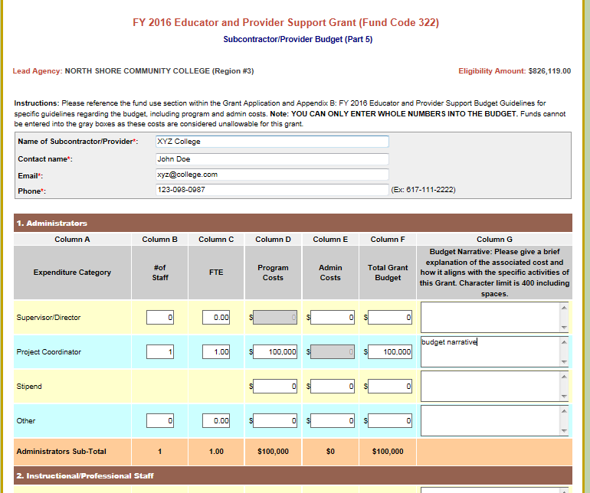

DISABLE SUBCONTRACTOR BUDGETS so grantee cannot get to subcontractor pages

* **PART 6 - FY 2019 BUDGET SUMMARY:** The Budget Summary combines all line items requested in the Lead Agency Budget. (This is read-only document).

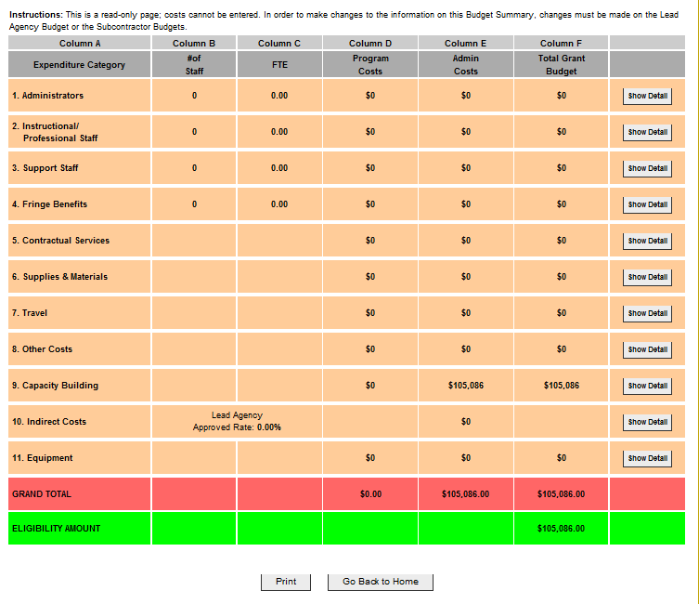

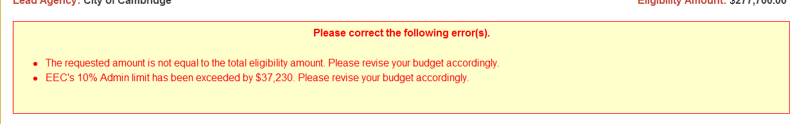

* **Part 7 - NARRATIVE QUESTIONS:** This section is being disabled.

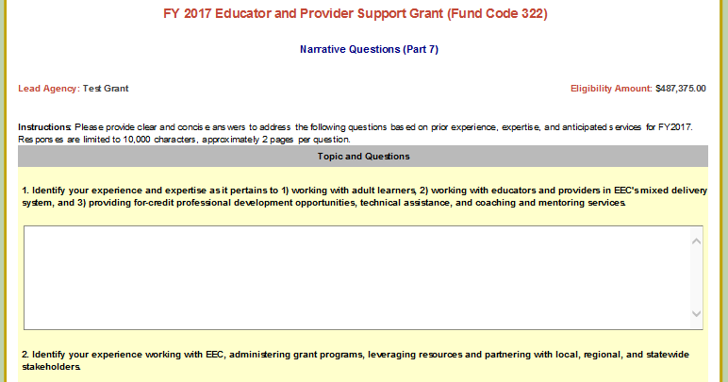

Close/Block/Disable section

* **Part 8 - PROJECTED DELIVERABLES:** This section is being disabled.

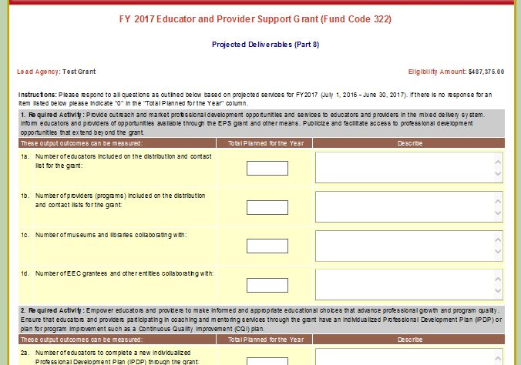

Close/Block/Disable section

**Part 9 - Required Grant Forms**

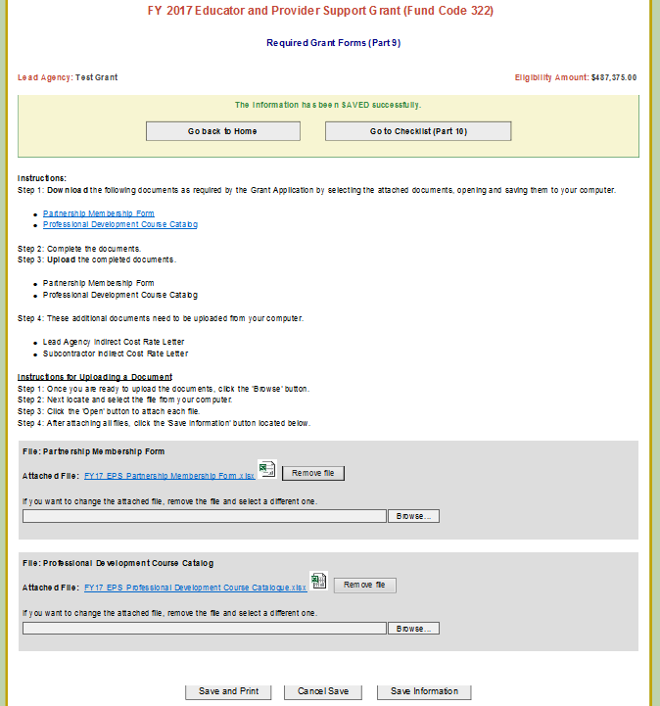

Note- we put asterisks next to documents that are required and alert messages should read if they are not submitted.

* Narrative Response (*required for submission)
* Career Pathways Sample Training Plan and Budget (*required for submission)
* Letters of Support (*required for submission)
* Key Personnel Statement (*required for submission)
* In-kind Contributions
* Lead Agency Indirect Cost Rate Letter

These documents need to be uploaded from your computer.

* + Narrative Questions
  + Career Pathways Sample Training Plan and Budget
  + Letters of Support
  + Key Personnel Statement
  + In-kind Contributions
  + Lead Agency Indirect Cost Rate Letter

**Instructions for Uploading a Document**  
Step 1: Once you are ready to upload the documents, click the 'Browse' button.  
Step 2: Next locate and select the file from your computer.  
Step 3: Click the 'Open' button to attach each file.  
Step 4: After attaching all files, click the 'Save Information' button located below.

Remove “Partnership Membership Form” and “Professional Development Course Catalogue”

Remove Subcontractor indirect cost rate letter

Add “Narrative Questions” (word document to be provided separately for applicants to download and then upload with submission.)

Add In-Kind Contributions (excel document to be provided separately for applicants to download and then upload with submission.)

Change text to "FY 2019 Early Childhood Education Career Pathways Grant (Fund Code 325)"

* **Part 10 - CHECKLIST -**

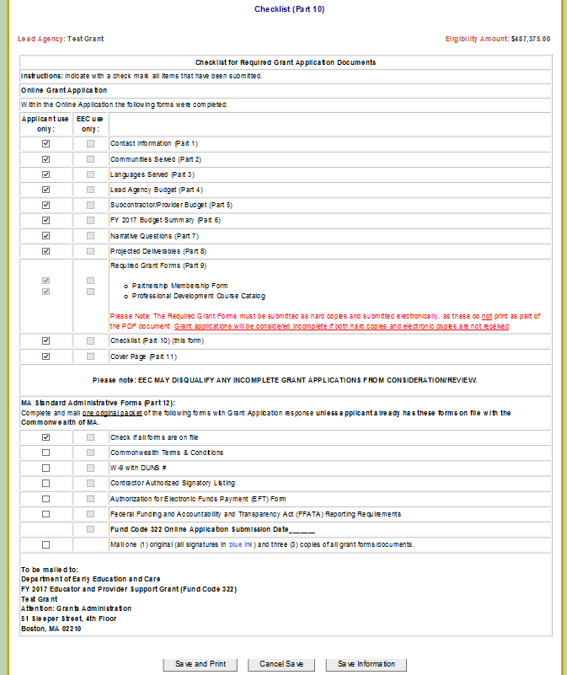

Block/Gray out Subcontractor/Provider Budget (Part 5), Narrative Questions (Part 7), and Projected Deliverables (Part 8)

Change Required Forms (Part 9) to

* Narrative Response
* Career Pathways Sample Training Plan and Budget
* Letters of Support
* Key Personnel Statement
* In-kind Contributions
* Lead Agency Indirect Cost Rate Letter

Change to Fund Code 325

Change text to FY 2019 Early Childhood Education Career Pathways Grant (Fund Code 325)

* **Part 11 - COVER PAGE:** Change introduction to:*Enter the Federal Tax ID.*
* **Please note:** Once the PDF is printed, the cover page must be signed with an original signature (in blue ink) by an authorized signatory.

Change text to "FY 2019 Early Childhood Education Career Pathways Grant (Fund Code 325)"

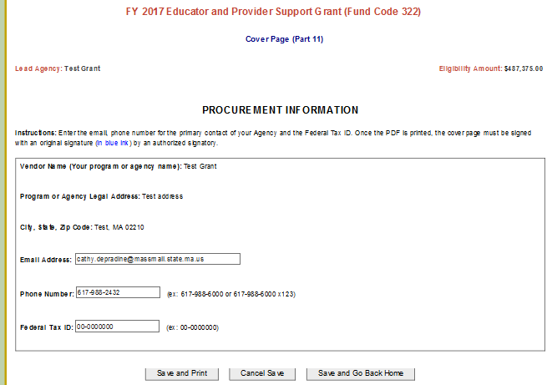

**New updated text**

* **PART 12 – ADMINISTRATIVE FORMS:** Please complete all of the required administrative forms and mail each of the forms with the rest of your Grant Application.

Please click the Submit button when you have completed your Online Application and are ready to submit your application to EEC for grant review. In order to save your information, you must press Submit.

**MA Standard Administrative Forms (Part 12)**

Applicants must complete and mail one original packet of the following forms with their Grant Application response.

Click the Print Summary button to Review your Grant Application as a PDF. This PDF must be submitted as a hard copy as part of the grant application.

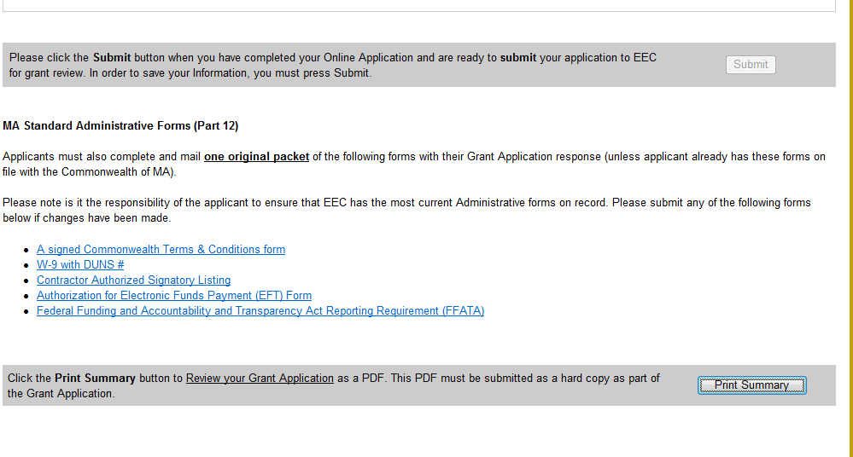

* **Obtain the appropriate signatures on the cover page (all signatures in blue ink) and additional attachments, if necessary.**
* **Mail the printed PDF summary and one (1) original and three (3) copies to EEC along with any necessary administrative forms. EEC’s mailing address is displayed at the bottom of the cover page.**

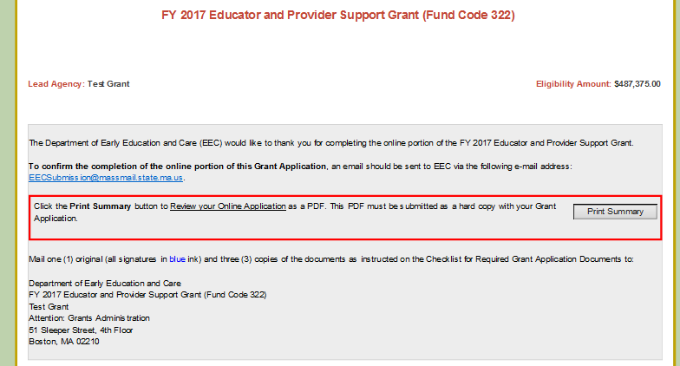

Change text to "FY 2019 Early Childhood Education Career Pathways Grant (Fund Code 325)"